EXPERIMENT-10

**Aim : To write a PL/SQL program for calculating the factorial of a given number.**

**Procedure :**

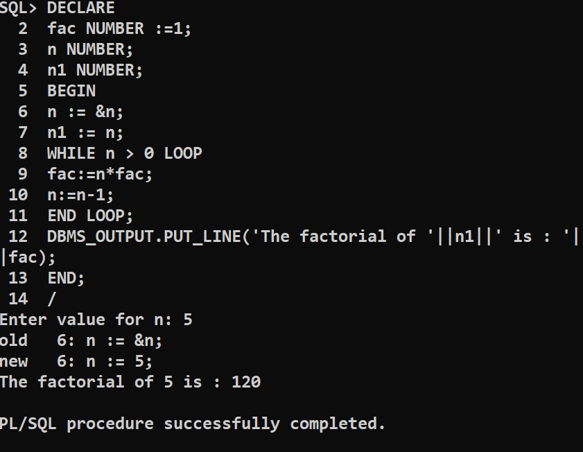

**OUTPUT : The pl/sql program to find factorial of a**

**given number is successfully executed**